Product Specification

ZK TECK PK
Shop # 1,Higher Ground Floor,Sarwar Center2,Behind 30-Mall Road Lahore,Pakistan
http://www.zkteco.net.pk/www.applecam.com.pk
Product Name: | Fire Alarm Control Panel
Part Number: | NW8000
Version: | Rev.1.0
Date: | 2020.03.25
Note:

Revision History
Rev. | Description | Author/Date | Checked By | Approver
1.0 | Released | Renyumei  Mar.25.2020 | Liwenhua | Shanquanyi

- Part Number : NW8000
- Dimension Drawing: (Unit: mm)
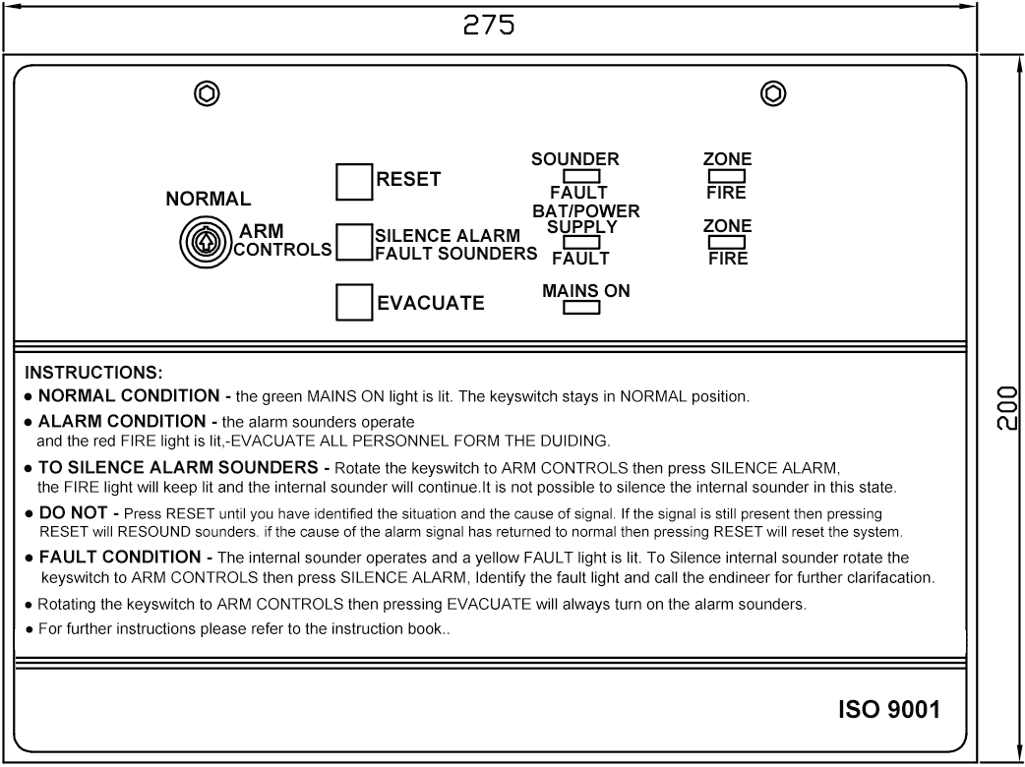

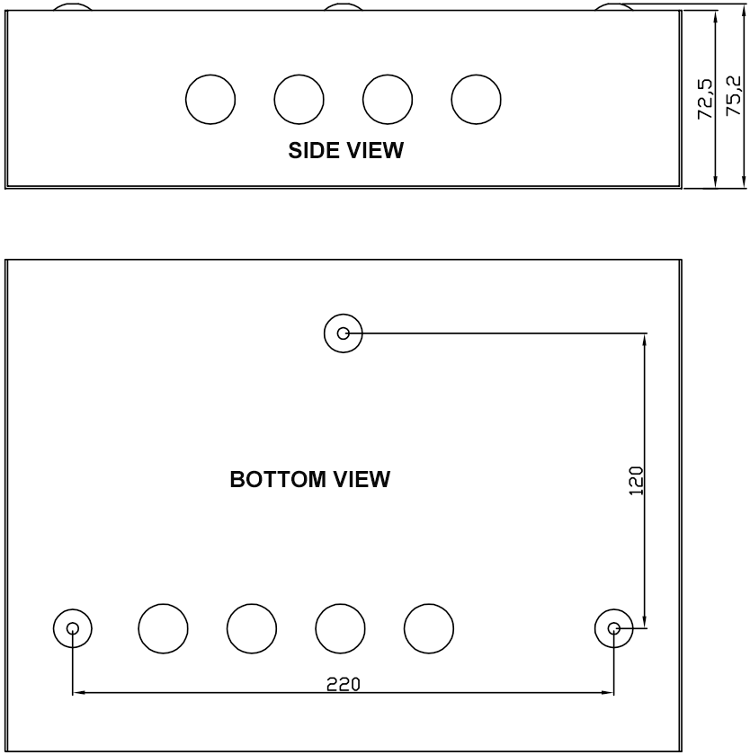

- Introduction
NW8000 1-4 zone control panel has been designed to meet the requirement of an easy to use fully functional fire alarm control panel. It has 2 sounder circuits.There is no configuration, simply connect the detectors & sounders and application.
- Electrical Specification
POWER SPECIFICATION |  |  | PARAMETER
MAINS SUPPLY VOLTAGE | FREQUENCY | RATED CURRENT | AC 220-230V | 50 Hz / 60 Hz | 130 mA
INTERNAL POWER SUPPLY |  |  | DC 27V nominal
LINE FAULT MONITORED FOR OPEN CIRCUIT |  |  | YES
TOTAL OUTPUT CURRENT LIMITED TO |  |  | 400 mA
AUXILIARY POWER OUTPUT |  |  | DC 27V nominal
MAINS SUPPLY MONITORED FOR FAILURE |  |  | YES
BATTERY CHARGER MONITORED FOR FAILURE |  |  | YES
BATTERIES MONITORED FOR DISCONNECTION/FAILURE |  |  | YES
DETECTOR CIRCUIT SPECIFICATION
NUMBER OF CIRCUITS |  |  | 1~4
LINE FAULT MONITORED FOR OPEN CIRCUIT |  |  | YES
LINE FAULT MONITORED FOR SHORT CIRCUIT |  |  | YES (can be disabled)
LINE FAULT MONITORED FOR DETECTOR REMOVAL |  |  | Yes, if End of Line Monitoring Unit fitted in place of End of Line Resistor
END OF LINE RESISTOR (SUPPLIED) |  |  | 6.8K Ω, 5% tolerance, 0.25W (color code - blue,grey,red,gold)
DETECTOR CONTINUITY DIODES |  |  | Silicon 1N4001 or Schottky type (required if End of Line Monitoring Unit fitted)
CALL POINT RESISTOR (NOT SUPPLIED) |  |  | 470 to 680 Ω, 0.25 or 0.5 W
MAXIMUM NUMBER OF SMOKE/HEAT DETECTORS PER ZONE |  |  | 20 (based on a total detector current of 2mA; each detector consuming 100uA). Note: If End of Line Monitoring unit is fitted, for correct operation max. voltage drop must not exceed 12 volts.
MAXIMUM NUMBER OF MANUAL CALL POINTS PER ZONE |  |  | No limit
SOUNDER CIRCUIT SPECIFICATION
NUMBER OF CIRCUITS |  |  | 2
END OF LINE RESISTOR (SUPPLIED) |  |  | 6.8K Ω, 5% tolerance, 0.25W (color code - blue,grey,red,gold)
LINE FAULT MONITORED FOR OPEN CIRCUIT |  |  | YES
LINE FAULT MONITORED FOR SHORT CIRCUIT |  |  | YES
OUTPUTS FUSED AT |  |  | 400 mA
MAXIMUM TOTAL OUTPUT CURRENT (ALL OUTPUTS) |  |  | 400 mA
MAXIMUM NO. OF BELLS @ 25mA EACH |  |  | - These quantities are examples only. Divide 400 by the consumption of  20 each sounder/bell in mA to calculate the maximum number.
MAXIMUM NO. OF ELECTRONIC SOUNDERS @ 20mA EACH
FUSE - ALL FUSES COMPLIANT TO IEC (EN 60127 PT2)
MAINS TERMINAL BLOCK |  |  | 200 mA T 20 mm Important: Exceeding the fuse ratings may render the equipment  400 mA F 20 mm unsafe and damage the output of this equipment. This damage is  1.0 A F 20 mm factory detectable and is not covered under warranty.
SOUNDER OUTPUTS (F1,F2)
BATTERY FUSE (F3)
AUXILIARY FIRE AND FAULT OUTPUTS
OUTPUT TYPE |  |  | Intended to drive external 24 V relays.
MAX. SOURCE CURRENT |  |  | 30 mA (relay resistance must be greater than 800Ωand relay must have”back EMF” diode fitted).
DOOR RETAINING MAGNETS |  |  | Use a RLP-24 relay driven from the Latching Fire Output. DO NOT USE PANEL POWER SUPPLY AS YOU WILL DRASTICALLY REDUCE BATTERY STAND-BY TIME.
CONNECTION BLOCK
LARGEST ACCEPTABLE CONDUCTOR SIZE |  |  | 2.5 ㎟
SMALLEST ACCEPTABLE CONDUCTOR SIZE |  |  | 0.75 ㎟
PHYSICAL
ENCLOSURE (WIDTH * HEIGHT * DEPTH) |  |  | 271*200*70 ㎜
BATTERY VOLUME DIMENSIONS (WIDTH * HEIGHT * DEPTH) |  |  | 170*70*65 ㎜(will accept typically 1.2 or 2.0 Ah sealed lead acid batteries)
WEIGHT (WITHOUT BATTERIES) |  |  | 2.3 Kg
IP RATING (to EN 60529) |  |  | IP30 (when correctly installed)
ENVIRONMENTAL
OPERATING TEMPERATURE |  |  | -10℃ to +40℃
HUMIDITY |  |  | 5% to 95% RH (non-condensing)
5. Packing Information：
One inner box consists of 1pcs.
5 inner boxes are packed in a carton box. (L*W*H= 67 * 24 * 36cm)

