Product Specification

Product Name: | Fire Alarm Control Panel
Part Number: | NW8200
Version: | Rev.1.0
Date: | 2022.02.25
Note:

Revision History
Rev. | Description | Author/Date | Checked By | Approver
1.0 | Released | Renyumei  Mar.15.2018 | Liwenhua | Shanquanyi

- Part Number : NW8200
- Dimension Drawing: (Unit: mm)
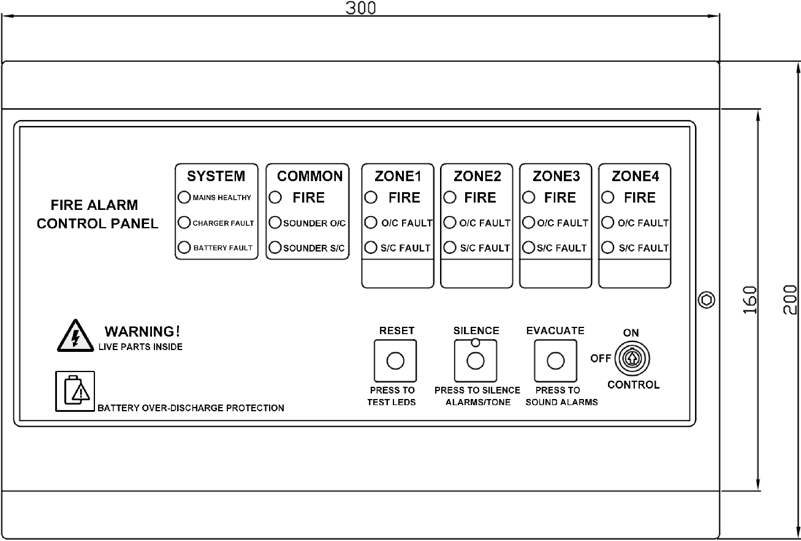

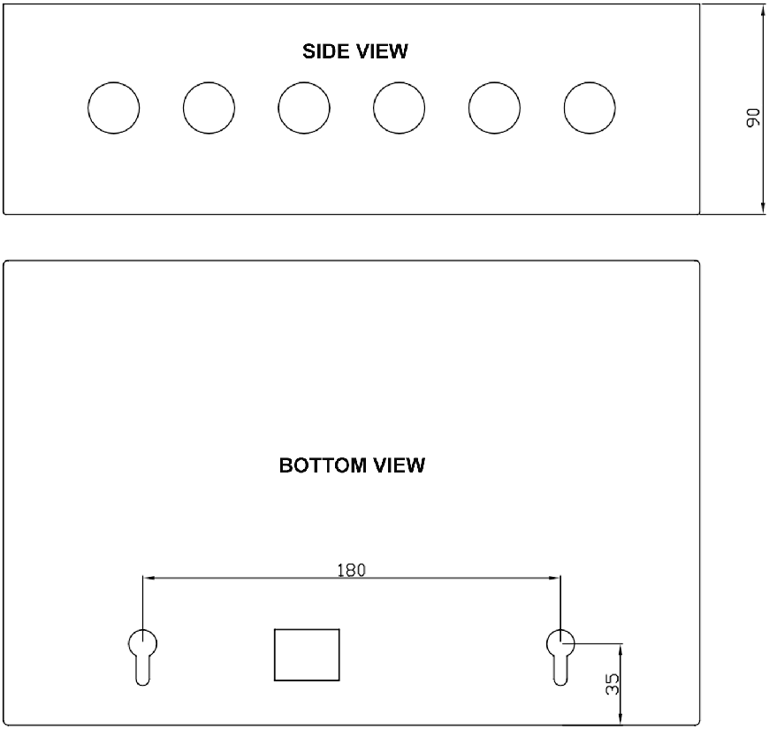

- Introduction
NW8200 1-4 zone control panel has been designed to meet the requirement of an easy to use fully functional fire alarm control panel. It has 2 sounder circuits. There is no configuration, simply connect
the detectors & sounders and application.
- Electrical Specifications
ITERMS | PARAMETER
MAINS VOLTAGE | 220AC +/- 10%, 50Hz
BATTERY VOLTAGE | 2x12V/1.3Ah
SYSTEM VOLTAGE | 29V DC NOMINAL
SYSTEM VOLTAGE RIPPLE | 200mV MAX
CHARGER SIZE | UP TO 4AH in 24 Hours
ZONE VOLTAGE | 22.5V DC NOMINAL
SOUNDER ALARM OUTPUTS | 2x250mA @ 24VDC (Nominal)
FAULT OUTPUT | 1xRELAY SELV (1AMAX)
FIRE OUTPUT | 1xRELAY SELV (1AMAX)
NUMBER OF ZONES | 1-4 Optional
MAXIMUM ZONE CAPACITY | 25 DEVICES PER ZONE
ZONE END OF LINE DEVICE | 4.7K RESISTOR
SOUNDER END OF LINE DEVICE | 4.7K RESISTOR
ZONE SHORT CIRCUIT PROTECTION | 100mA
OVER DISCHARGE PROTECTION | 19V DC

- State LEDs
STATE | LED CONDITION
Mains Healthy | Power supply indicating LED (green), it lights when the power supply
Charge Fault | General Disable indication LED (yellow). It will light when any Disable occurs
Bat. Fault | Battery fault indication LED (yellow). It will light when battery fault occurs
Common Fire | General fire alarm indicating LED (red). Constantly light until the fire alarm is cleared
SOUNDER O/C | Fault indication LED (yellow). It will light when there is an open circuit fault of that sounder circuit.
SOUNDER S/C | Fault indication LED (yellow). It will light when there is a short circuit fault of that sounder circuit.
Zone Fire | Red LED, there are 4 zone fire indicate LED. The zone fire LED will flash when the fire alarm occurs in corresponding Zone. It will light after the Silence.
O/C Fault | Fault indicator (yellow). It will light when there is an open circuit fault in the field wiring of that zone
S/C Fault | Fault indicator (yellow). It will light when there is a short circuit fault in the field wiring of that zone
Silence | Silencing indicating LED (yellow). It lights when the internal buzzer or sounder is muted.
- Operation Key
There are 3 operation buttons on the keypad. Before operation, turn the control key to the ON position.
STATE | LED CONDITION
Reset | The button is used to confirm reset operation and test LEDs.
Silence | The button is used to silence all alarms
Evacuate | The button is used to activate the alarm in the event of an emergency and re-sound an alarm after the alarm has been silenced.

7. Packing Information
One inner box consists of 1pcs.
5 inner boxes are packed in a carton box. (L*W*H= 70 * 27.5 * 36cm)

