Product Specification

Product Name: | Fire Alarm Control Panel
Part Number: | NW8100
Version: | Rev.1.0
Date: | 2020.02.22
Note:

Revision History
Rev. | Description | Author/Date | Checked By | Approver
1.0 | Released | Renyumei  2.25.2022 | Liwenhua | Shanquanyi

- Part Number : NW8100
- Dimension Drawing: (Unit: mm)
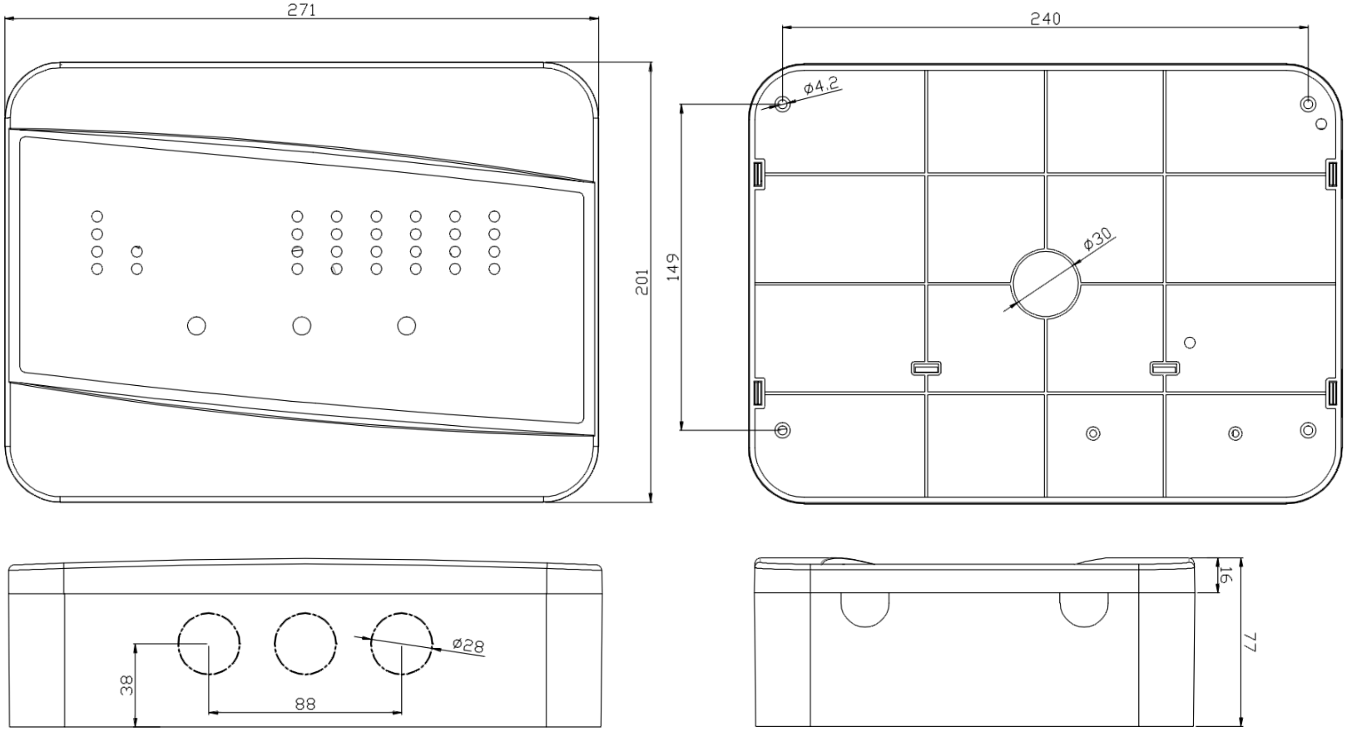

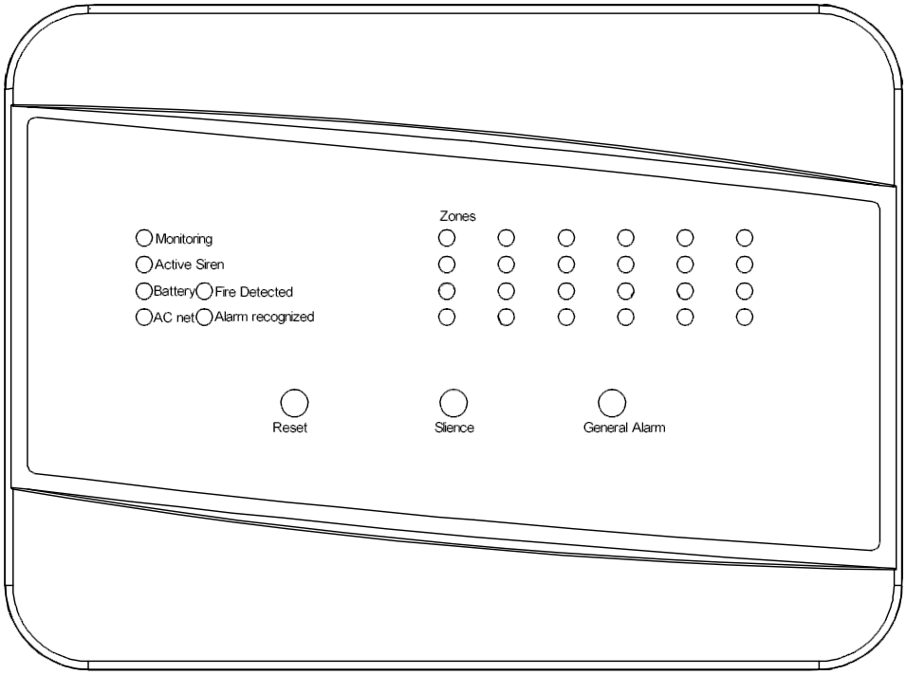
- Introduction
NW8100 1-24 zone control panel has been designed to meet the requirement of an easy to use fully functional fire alarm control panel. It has 1 sounder circuits.There is no configuration, simply connect the detectors & sounders and application.

POWER SPECIFICATION |  |  | PARAMETER
MAINS SUPPLY VOLTAGE | FREQUENCY | RATED CURRENT | AC 220-230V | 50 Hz / 60 Hz | 130 mA
INTERNAL POWER SUPPLY |  |  | DC 27V nominal
LINE FAULT MONITORED FOR OPEN CIRCUIT |  |  | YES
AUXILIARY POWER OUTPUT |  |  | DC 27V nominal
MAINS SUPPLY MONITORED FOR FAILURE |  |  | YES
BATTERY CHARGER MONITORED FOR FAILURE |  |  | YES
BATTERIES MONITORED FOR DISCONNECTION/FAILURE |  |  | YES
DETECTOR CIRCUIT SPECIFICATION
NUMBER OF CIRCUITS |  |  | 1~24
The total number of connections does not exceed |  |  | 50
CALL POINT RESISTOR (NOT SUPPLIED) |  |  | 470 to 680 Ω, 0.25 or 0.5 W
MAXIMUM NUMBER OF SMOKE/HEAT DETECTORS PER ZONE |  |  | 20 (based on a total detector current of 2mA; each detector consuming 100uA). Note: If End of Line Monitoring unit is fitted, for correct operation max. voltage drop must not exceed 12 volts.
MAXIMUM NUMBER OF MANUAL CALL POINTS PER ZONE |  |  | No limit
SOUNDER CIRCUIT SPECIFICATION
NUMBER OF CIRCUITS |  |  | 1
MAXIMUM TOTAL OUTPUT CURRENT (ALL OUTPUTS) |  |  | 400 mA
MAXIMUM NO. OF BELLS @ 25mA EACH |  |  | - These quantities are examples only. Divide 400 by the consumption of  20 each sounder/bell in mA to calculate the maximum number.
MAXIMUM NO. OF ELECTRONIC SOUNDERS @ 20mA EACH
FUSE - ALL FUSES COMPLIANT TO IEC (EN 60127 PT2)
AC FUSE ( FUSIVEL AC) |  |  | 500 mA 20 mm Important: Exceeding the fuse ratings may render the equipment  unsafe and damage the output of this equipment. This damage is  1A 20 mm factory detectable and is not covered under warranty.
BATTERY FUSE (FUSIVEL BATERIA)
AUXILIAR AND RELAY
AUXILIAR |  |  | Internal output 27V
RELAY |  |  | NF C NA NF and C Normally closed output，NA and C Normally open output
CONNECTION BLOCK
LARGEST ACCEPTABLE CONDUCTOR SIZE |  |  | 2.5 ㎟
SMALLEST ACCEPTABLE CONDUCTOR SIZE |  |  | 0.75 ㎟
PHYSICAL
ENCLOSURE (WIDTH * HEIGHT * DEPTH) |  |  | 300*200*90 ㎜
BATTERY VOLUME DIMENSIONS (WIDTH * HEIGHT * DEPTH) |  |  | 170*70*65 ㎜(will accept typically 1.2 or 2.0 Ah sealed lead acid batteries)
WEIGHT (WITHOUT BATTERIES) |  |  | 2.3 Kg
IP RATING (to EN 60529) |  |  | IP30 (when correctly installed)
ENVIRONMENTAL
OPERATING TEMPERATURE |  |  | -10℃ to +40℃
HUMIDITY |  |  | 5% to 95% RH (non-condensing)
- Electrical Specification
5. Packing Information：
One inner box consists of 1pcs.
5 inner boxes are packed in a carton box. (L*W*H= 30 * 20 * 9cm)

